ГБОУ СОШ № 1

Класс: 3

Предмет: английский язык

Автор задания: Бизяева Ольга Федоровна

1. *Read and complete the table.*

I’ve got a pet rabbit. His name is Jack. He’s got a fat body, long pink ears and big eyes. Jack can run and he can jump, too! He’s very funny.

|  |  |
| --- | --- |
| Pet |  |
| Name |  |
| Body |  |
| Ears |  |
| Eyes |  |
| Can |  |

1. *Write about your pet.*

ГБОУ СОШ № 1

Класс: 7

Предмет: английский язык

Автор задания: Бизяева Ольга Федоровна

1. *Look at the texts*

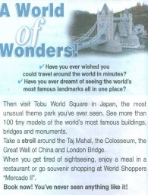 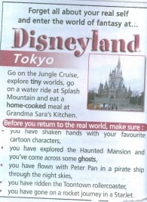

1. *Read and say. Where can you:*

* see famous landmarks?
* have lunch?
* have a scary experience?
* see small buildings?
* see funny characters?

1. *What would you choose and why?*

ГБОУ СОШ № 1

Класс: 10

Предмет: английский язык

Автор задания: Антипова Анастасия Владимировна

*Discuss the following questions with a partner*

1. Are you a theatregoer?
2. What kind of plays do you prefer?
3. What famous theater do you know?
4. What famous theatre would you like to visit? Why?

*Now you’re going to watch the video excursion about the most famous English theatre “The Globe”. Your task is to mark the statements true or false*

1. The Globe was built in the 17th century.
2. All the plays were shown during the day.
3. All the actors were women.
4. All the people could afford to buy a ticket to the Globe.
5. Umbrellas weren’t allowed.
6. Only Shakespeare’s plays were shown at the theatre.
7. The signs of Zodiac represent the Heavens.
8. The stage represents the Earth.
9. The trapdoor represents the Hell.
10. The globe had burned twice in the 18th century.